**MULTIPLE ROWS ISSUE**

Issue: MULTIPLE ROWS ISSUE

Sample Ticket: 000000271904085

Resolution Steps:

1. Take order id from USH portal.
2. In Queue Expeditor Tool enter your Order number and then search(Query) to check for **Error.**
3. Check the error like below

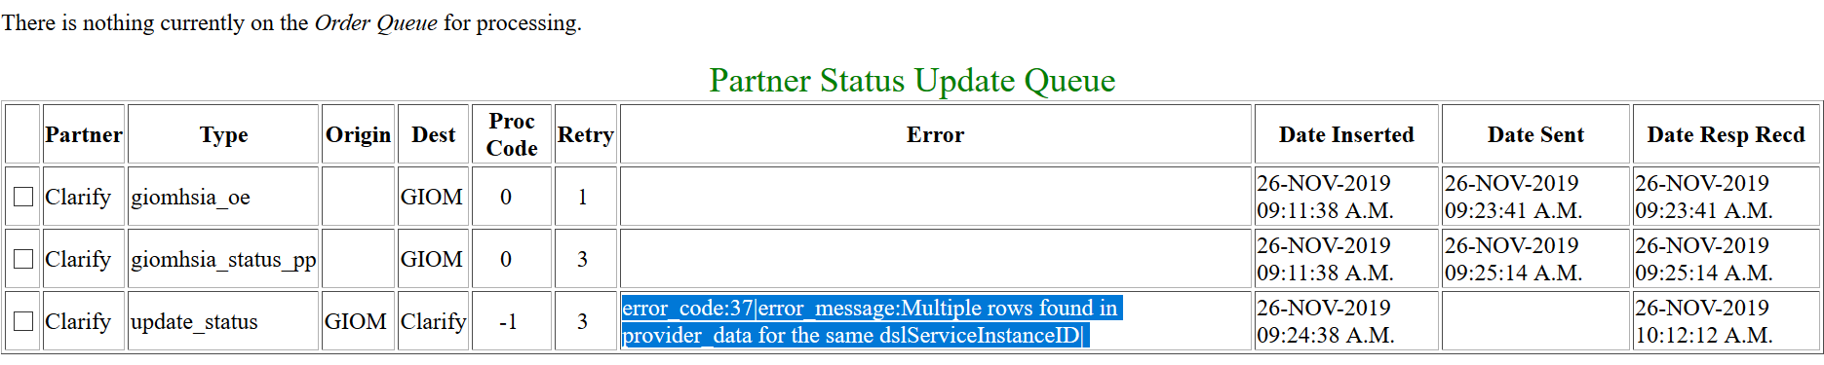

1. select count(*) from provider_data where dslserviceinstanceid = '1470815_1;

->If out put will come more than one we need to delete duplicate rows.

5) After that delete the duplicate rows from provider_data table.

->check properly and delete duplicate rows accordingly.

delete from provider_data where rowid=(select max(rowid) from provider_data where dslserviceinstanceid = '1470815_1);

6)Then send UNR(update_status) from Queue Expeditor tool.